DATA ANALYTICS

TITLE-Unveiling the Virtual Classroom: An In-depth Analysis of the

Online Education System

INTRODUCTION:

Description:

Online classes and technology have emerged as a superhero during the lockdown days. We have all been under house arrest but are still connected with the world of education. Due to the lockdown, students have not been able to stay connected with the outer world and the lack of exposure is evident. The only reprieve for the students’ mental well-being has been the transition to online classes. Teachers made sure that the learning for students was not compromised, so they took a great leap forward to find solutions and create new learning environments for their students to ensure that learning never stops. With the rapid advancements in technology and the widespread availability of internet access, online education has gained significant popularity in recent years. This project aims to delve deep into the various aspects of online education, examining its strengths, weaknesses, opportunities, and challenges.

Purpose:

The purpose of an online education system is to provide accessible and flexible learning opportunities through digital platforms. Online education has gained significant popularity due to its numerous advantages

**Accessibility:** Online education eliminates geographical barriers, making quality education available to a global audience. People from different parts of the world can access courses and programs offered by institutions they might not have been able to attend in person.

**Flexibility:** Online education allows learners to create their own schedules. This is particularly beneficial for individuals who have work, family, or other commitments that make attending traditional classes difficult. Students can learn at their own pace and fit their studies around their existing responsibilities.

**Cost-Effectiveness:** Online education can be more cost-effective than traditional education. It eliminates the need for commuting and offers the opportunity to save on accommodation expenses. Additionally, many online courses and resources are more affordable than traditional classroom-based education.

LITERATURE SURVEY:

Existing problem:

**Lack of Engagement**: Online courses can sometimes lack the interactive and engaging elements of traditional classrooms. Students might feel isolated and struggle to stay motivated without face-to-face interactions with instructors and peers.

**Technical Issues:** Online learning heavily relies on technology, and technical issues such as internet connectivity problems, software glitches, or hardware limitations can disrupt the learning process and cause frustration.

**Self-Discipline and Time Management:** Online learning requires a high level of self-discipline and time management skills. Some students may find it challenging to organize their study schedule and stay focused without the structure of a traditional classroom

Proposed Solution:

The outcomes of this project will provide valuable insights for educational institutions, policymakers, and online learning platforms to enhance the effectiveness and accessibility of online education. This analysis of the online education system aims to contribute to the ongoing dialogue on the future of education and help shape a more inclusive, engaging, and effective learning environment in the digital age.

THEORITICAL ANALYSIS:

Diagrammatic overview of the project:

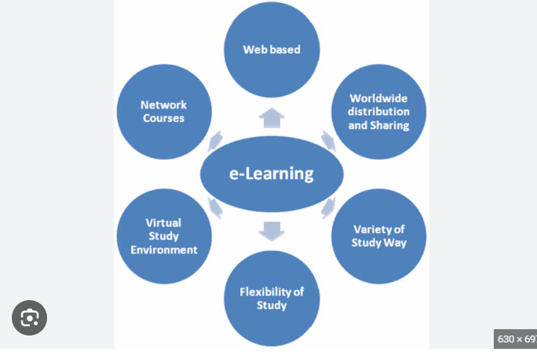

Hardware/Software designing:

**IBM Cognos:** Data-driven business intelligence and performance management platform for generating actionable insights and reports.

**Python:** A versatile and powerful programming language widely used for data analytics, statistical analysis, and machine learning applications.

**Flask:** A lightweight web framework often used to deploy data analytics APIs and web applications.

EXPERIMENTAL INVESTIGATIONS:

**1.Introduction:**

Online education, also known as e-learning, has revolutionized the way people access and engage with learning opportunities. With the rapid advancement of technology, the traditional boundaries of education have expanded beyond physical classrooms and campuses. Online education leverages digital platforms, the internet, and various multimedia tools to deliver educational content and foster learning interactions.

**2.Data Collection:**

Identifying relevant and reliable sources of economic data, including international organizations, government agencies, financial institutions, and reputable research publications.

Gathering data on key economic indicators such as GDP, inflation rates, unemployment rates, trade balances, exchange rates, interest rates, stock market indices, and commodity prices.

Ensuring data covers a substantial period to capture historical trends and variations.

**3.Data Cleaning and Preparation:**

Cleaning and preprocessing the collected data to ensure consistency, accuracy, and compatibility for analysis.

Handling the missing values, outliers, and data inconsistencies appropriately.

Transforming data into suitable formats and structures for analysis.

**4.Exploratory Data Analysis (EDA):**

Conducting EDA to get a preliminary understanding of the data and uncover patterns, correlations, and insights.

Visualizing the data using charts, graphs, and interactive visualizations to highlight significant economic trends.

**5.Time-Series Analysis:**

Applying time-series analysis techniques to understand the evolution of economic indicators over time.

Identifying seasonal patterns, trends, and cyclical variations that may influence the global economy.

**6.Sentiment Analysis:**

Utilizing sentiment analysis on economic news articles, social media, and other text data to gauge public and investor sentiment's impact on the economy.

Identifying positive and negative sentiments related to economic events and assess their potential influence on economic trends.

**7.Economic Forecasting:**

Developing predictive models using machine learning algorithms to forecast economic indicators in the short and medium term. Validating the accuracy of the models through cross-validation and back testing.

**8.Economic Impact of Events:**

Investigating the impact of significant global events (e.g., pandemics, geopolitical events, policy changes) on the global economy using data-driven methodologies.

Evaluating how these events have historically affected economic indicators and identify potential implications for the future.

**9.Regional and Country-Level Analysis:**

Performing regional and country-level analyses to compare economic performance, identify variations, and assess the interconnectedness of different economies.

Analyse factors contributing to economic growth or decline in specific regions or countries.

**10.Visualization and Reporting:**

Creating informative and visually appealing dashboards and reports to present the findings of the analysis. Based on the analysis, provide actionable recommendations to policymakers, businesses, and investors to make informed decisions related to the global economy.

Flow chart:

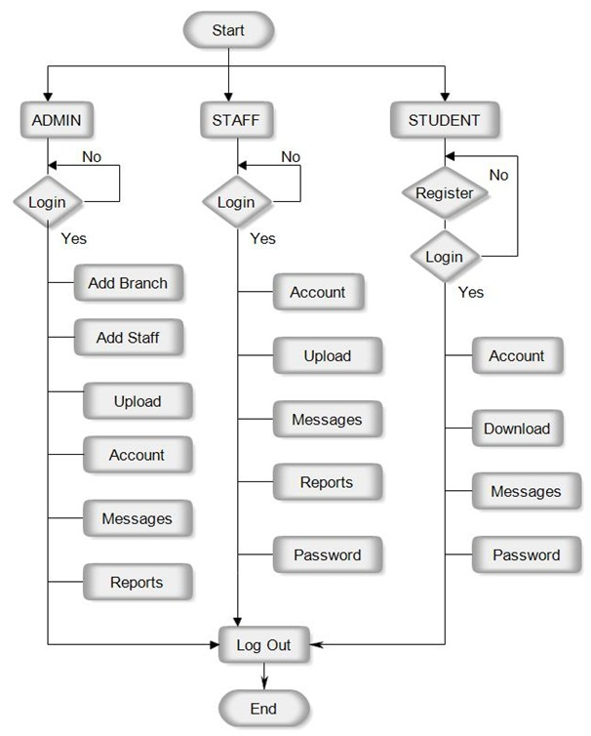

ADVANTAGES:

**Flexibility:** One of the most significant advantages of online education is its flexibility. Students can access course materials, lectures, and assignments at their own pace and schedule. This is particularly beneficial for individuals who are working or have other commitments.

**Accessibility**: Online education breaks down geographical barriers, allowing students to access courses and programs offered by institutions from around the world. This is especially advantageous for those who might not have access to quality education locally.

**Wide Range of Courses**: Online education offers a diverse range of courses, from academic subjects to vocational skills, which can cater to a wide variety of interests and career goals.

**Cost-Effectiveness:** Online courses are often more affordable than traditional in-person courses. Students can save money on commuting, accommodation, and other expenses associated with attending a physical campus.

DISADVANTAGES:

**Lack of Face-to-Face Interaction:** Online education lacks the in-person interaction that traditional classroom settings provide. This can result in feelings of isolation and hinder the development of social skills.

**Limited Practical Skills:** Some fields of study, particularly those that require hands-on training or practical skills, may be challenging to teach effectively in an online environment.

**Potential for Cheating:** Online assessments can be more susceptible to cheating and academic dishonesty, as it's harder to monitor students remotely.

**Technical Challenges:** Online learning relies heavily on technology and internet connectivity. Technical issues can disrupt the learning process, especially for students who don't have access to reliable equipment or high-speed internet.

APPLICATIONS:

**K-12 Education**: Online education is used in primary and secondary education to supplement traditional classroom teaching. It offers personalized learning experiences, interactive content, and remote access to educational resources, enabling students to learn at their own pace.

**Higher Education**: Many universities and colleges offer online courses and degree programs, allowing students to pursue higher education while maintaining flexibility in their schedules. This is particularly beneficial for working professionals and those who can't attend on-campus classes.

**Professional Development**: Online education is widely used for professional development and training. Companies provide online courses to train their employees in various skills, including leadership, project management, technical skills, and more.

**Vocational Training:** Online education is used to provide vocational training in fields like healthcare, construction, culinary arts, and more. This allows individuals to learn practical skills required for specific careers.

**Entrepreneurship and Business Courses**: Aspiring entrepreneurs can access online courses that cover various aspects of starting and running a business, including business planning, marketing, finance, and more.

CONCLUSION:

In conclusion, the advent of online education systems has ushered in a transformative era in the field of learning and instruction. With their remarkable flexibility, accessibility, and adaptability, these systems have redefined the way education is delivered and consumed. The applications of online education are vast and varied, spanning from K-12 education to professional development, vocational training, and beyond. They have facilitated personalized learning experiences, bridged geographical gaps, and empowered learners of all ages to acquire knowledge and skills at their own pace.

Online education has not only democratized learning by making quality education available to a broader audience but has also empowered individuals to take control of their own educational journeys. It has enabled students to balance their education with work, family, and other commitments, fostering a culture of lifelong learning. Additionally, online education has proven invaluable in times of crises, such as the COVID-19 pandemic, when traditional learning models were disrupted.

However, the success of online education is not without challenges. Ensuring the quality of content, maintaining student engagement, addressing technological barriers, and fostering social interactions in virtual spaces remain ongoing concerns. Striking the right balance between digital instruction and in-person experiences, where necessary, will be crucial in harnessing the full potential of online education systems.

As technology continues to evolve, so will online education systems. Incorporation of artificial intelligence, virtual reality, and other emerging technologies holds the promise of even more immersive and effective learning experiences. The future of education will likely involve a harmonious blend of online and traditional methods, catering to the diverse needs and preferences of learners.

In essence, the online education system has not only opened new avenues for knowledge dissemination but has also sparked a profound shift in the educational landscape. Its impact resonates across formal education, professional training, skill enhancement, and personal enrichment. As educators, learners, and innovators continue to collaborate and refine these systems, the journey of online education remains an exciting exploration into the possibilities of modern learning.

FUTURE SCOPE:

The future scope for the online education system is incredibly promising, as advancements in technology and evolving educational paradigms continue to reshape the way we learn and teach. Here are some key areas of future growth and development for online education:

**Advanced Technology Integration:** The integration of artificial intelligence, machine learning, and data analytics will enable personalized learning experiences. AI can assess individual learning patterns and preferences, adapting content and pacing to optimize learning outcomes.

**Virtual and Augmented Reality:** Virtual and augmented reality technologies will create immersive learning environments, allowing students to engage with subjects in ways previously thought impossible. Complex concepts can be visualized, enhancing understanding and retention.

**Microlearning and Bite-sized Content**: Short, focused content modules will gain prominence, catering to learners' increasingly busy lifestyles. Microlearning facilitates quick skill acquisition and knowledge retention, making it ideal for just-in-time learning.

**Global Collaboration and Cross-Cultural Learning**: Online platforms will continue to connect learners and educators from around the world, fostering cross-cultural understanding and collaboration on a scale previously unimaginable.

**Emergence of New Subjects**: As technology and societal trends evolve, new subjects and disciplines will emerge, leading to the development of courses and programs catering to these emerging fields.

**Dash Board**

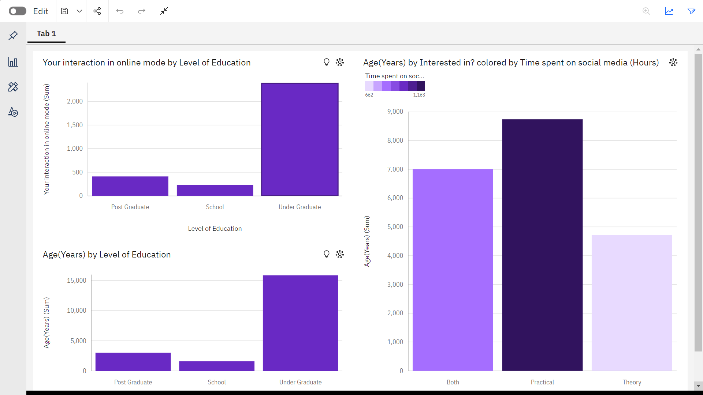

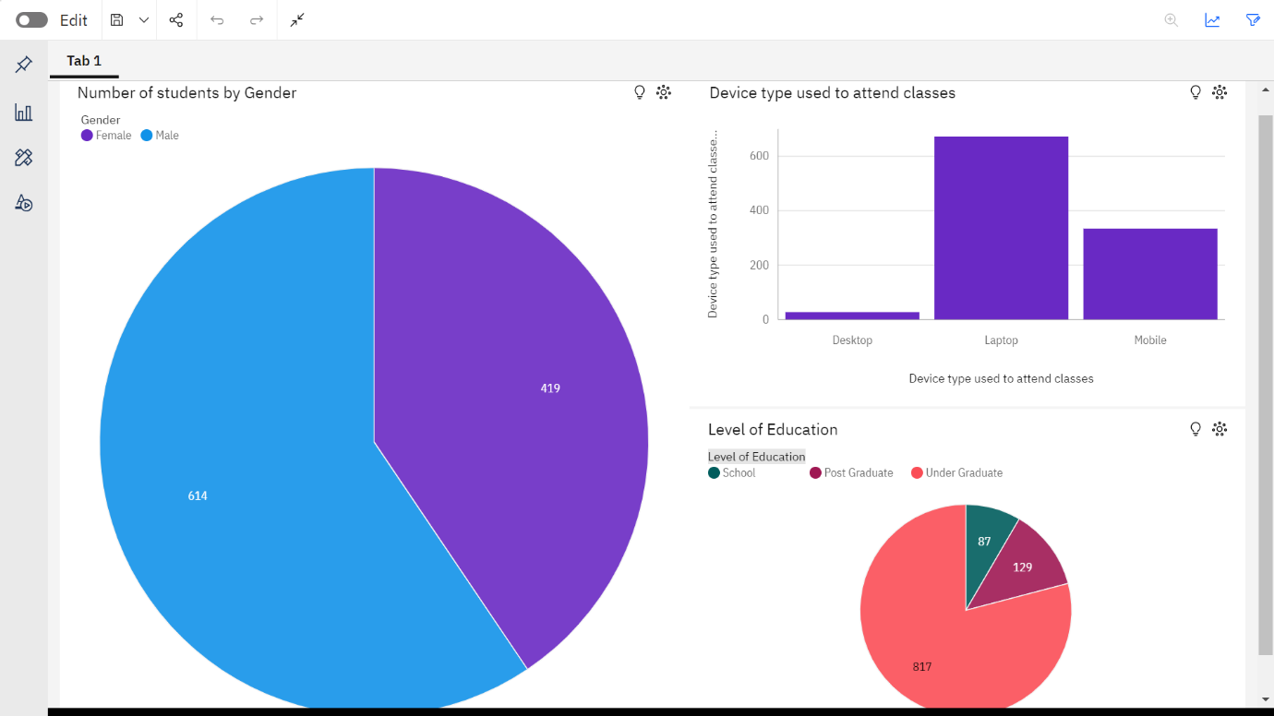

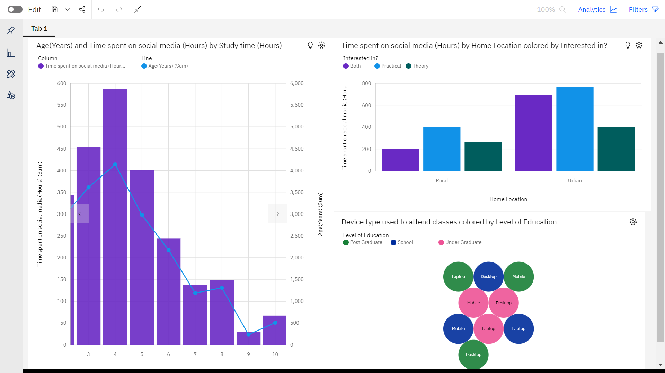

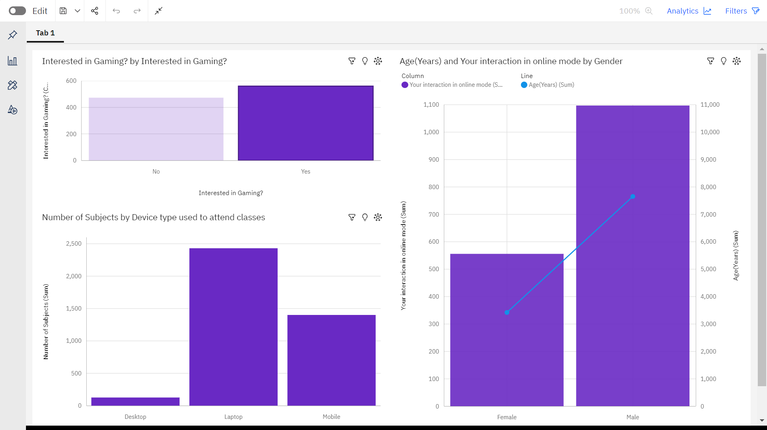

**Reports**

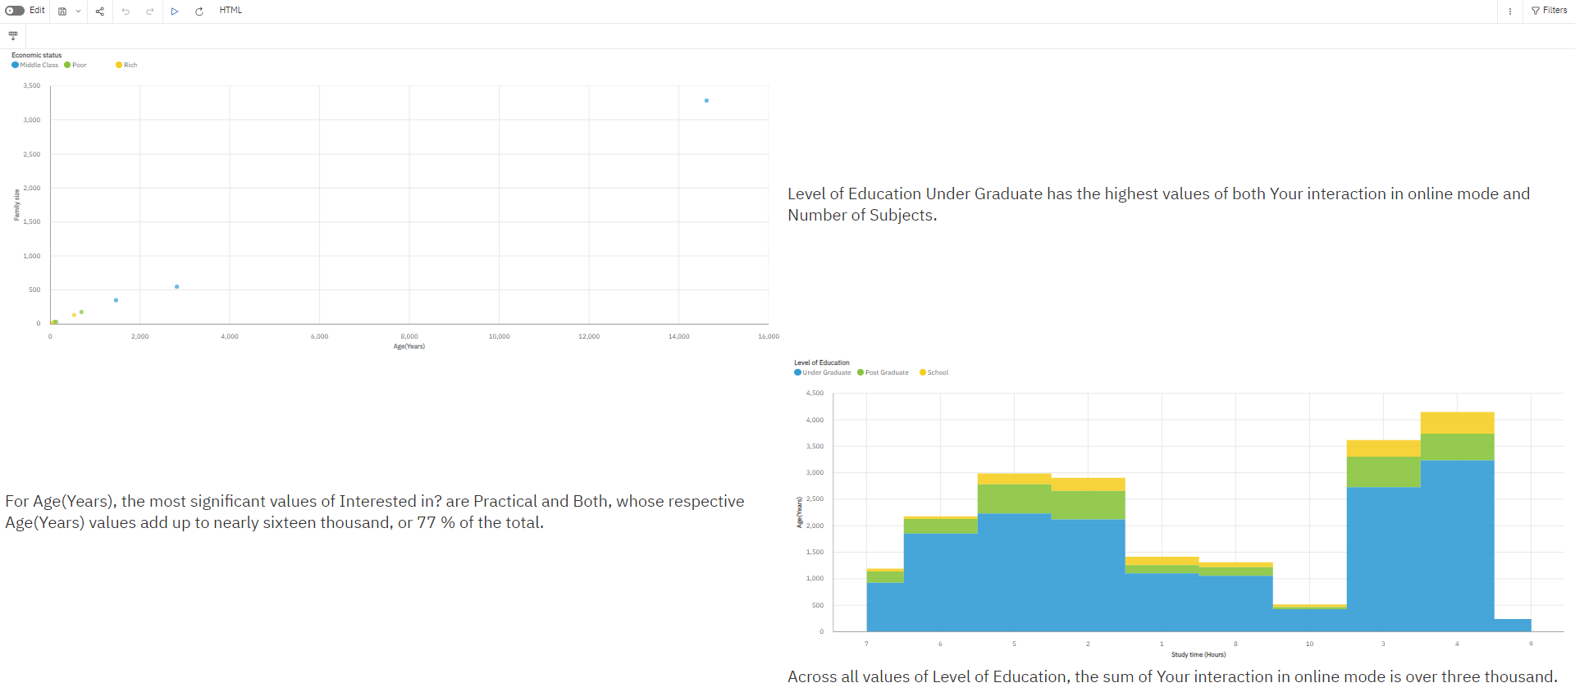

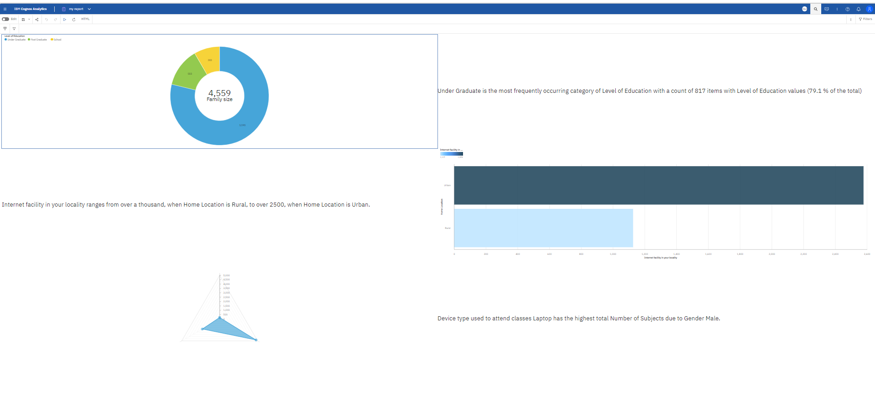

**MY Visualization**

